**FHIR Command Line Application to replicate Patient records:**

Table of Contents

Overview 2

JDK 2

Download and Install 2

Java Home Variable 2

Verify Java 2

STS 2

Spring Tool Suite Download and Install 2

Installed JRE 3

Import the Project 3

Export the Runnable jar file 3

Execute .jar file: 4

# Overview

This document outlines the steps required to setup a Java development environment. The steps should be performed in order on a pristine machine for best results.

# JDK

## Download and Install

1. From the browser navigate to <http://www.oracle.com/technetwork/java/javase/downloads/jdk8-downloads-2133151.html>
2. Download jdk-8u111-windows-x64.exe file.
3. Run the installer file and install Java and continue with the default settings

## Java Home Variable

1. Open the Control Panel and select System > Advanced System Settings
2. From the advanced tab, click on the “Environment Variables” button.
3. Create a new System Variable with the name “JAVA_HOME” and a value of the directory where the JDK is installed (most likely C:\Program Files\Java\ jdk1.8.0_111)

## Verify Java

Run the below command in command prompt to verify the java installation.

**java -version**

It will output something like below:

**java version "1.8.0_111"**

**Java(TM) SE Runtime Environment (build 1.8.0_111-b14)**

# STS

## Spring Tool Suite Download and Install

1. From a web browser, navigate to https://spring.io/tools
2. Click “Download STS”
3. Using Windows Explorer, navigate to the folder where executable file was downloaded.
4. Unzip the STS package to the desired folder .
5. Spring Tool Suite can be run by double clicking the “STS.exe” file in the “/sts-bundle/sts-x.x.x.RELEASE” folder. When STS starts up, select your desired workspace (using the default is recommended). NOTE: If you have a previous version of STS or Eclipse installed, it is recommended to use a different workspace folder as there may be incompatibilities between the two workspaces that could cause problems.

### Installed JRE

1. From the Menu Bar, select Window>Preferences.
2. Select Java>Installed JREs
3. Select Add, select Standard VM, and click next.
4. For the JRE home, click the Directory button and select the directory where the JDK 1.8 was installed (most likely C:\Program Files\Java\ jdk1.8.0_111).   
   This should populate the rest of the values once selected.
5. Click finish
6. From the Installed JREs list, ensure that jdk1.8 is checked, NOT the jre.
7. Click OK to close window.

## Import the Project

Extract the project zip file into the file system. And follow the below procedure.

Click on File -> Import -> Expand the "General" and select "Existing projects into Workspace" and click on "next".

In the window select "Select root directory:" and browse the extracted project folder.

and click on "Finish".

### Export the Runnable jar file

Right click on the project and click on "Export"

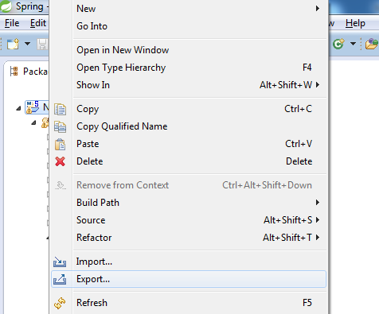

Export window will be opened, here search for "java"

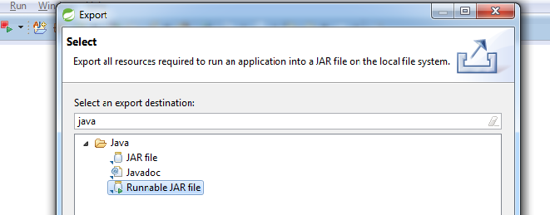

and select "Runnable JAR file", click on "next".

"Runnable Jar File Export" window will be opened. In the "Launch configuration" drop down select "Main – FHIR replicate patients"

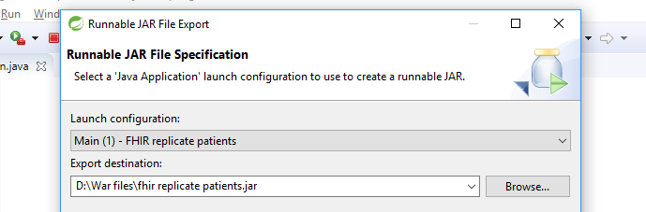

In the Export Destination browse the directory or folder to where you want to save the exported .jar file. Click on "Finish", the jar file will be exported to the browsed directory.

### Execute .jar file:

Copy the runnable jar file in to a folder. (D:/Users/User)

Open the command line click on window and search for "cmd" and click on enter.

In the command line navigate to the folder where the runnable jar file is copied.

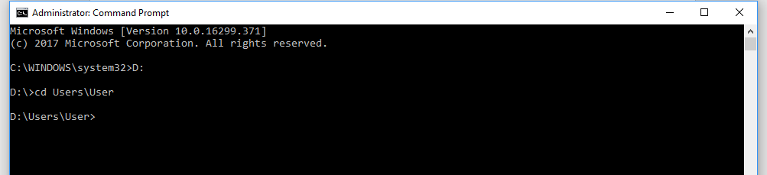

and type the below command and hit enter

**java -jar "jar_name.jar"**

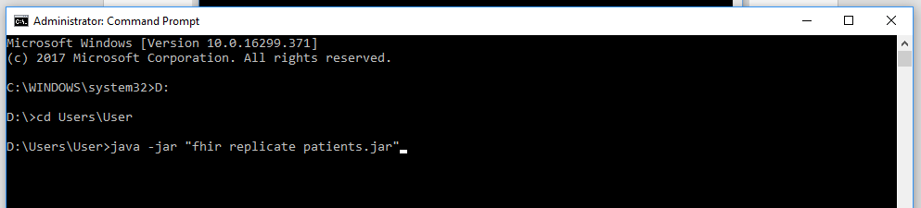

Jar file will be executed and it prompts for the database name.

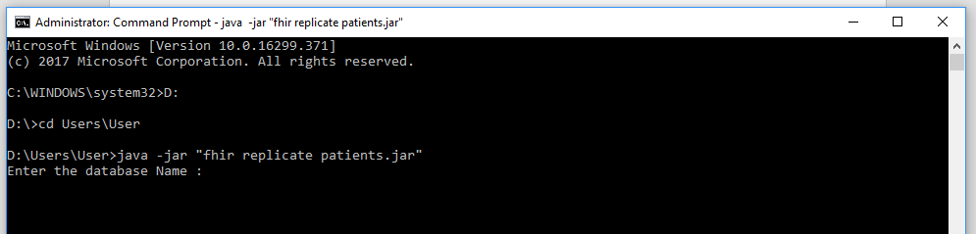

Enter the fhir database name and hit enter, the program will connect with the database provided and search for the patient tables and displays the available records. Then it will prompt for the number of records, the patient resource should have.

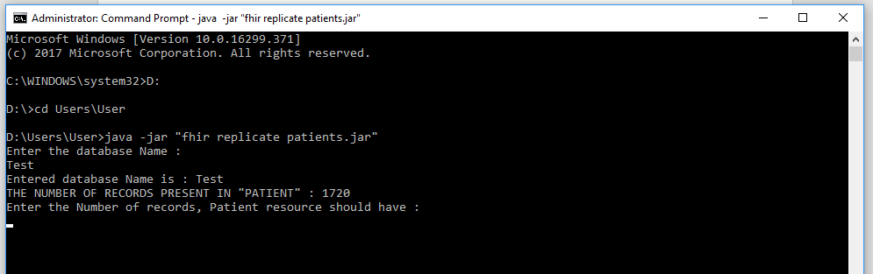

Provide the number and hit enter.

For example, you are expecting 2000 records to be present for patient, then enter the number 2000. The patients will be replicated.

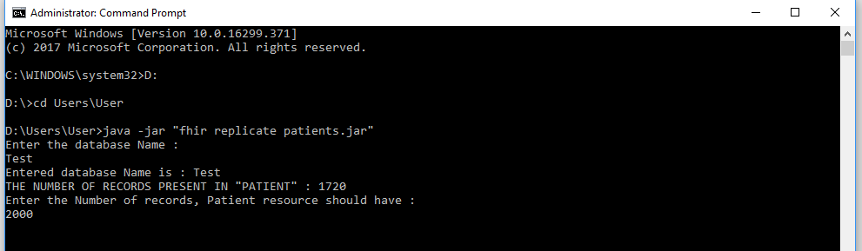

Once the process has been completed you’ll get the success message and it’ll displays the number of records presents after replication.

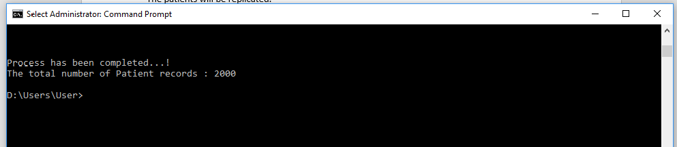

We’re done.